English 10H Second Quarter Theme: PERSPECTIVES
In the second quarter, we will be discussing the importance of perspective when discussing literature—and life. How we view our own experiences and life events depends largely on our individual perspectives. For example, some see a glass half empty, some half full. Many times, our experiences can be interpreted in different ways if we manage to look at them from different perspectives.
As an exercise in looking at things from a different perspective, examine the following visuals, and then answer the questions beneath each of them. You may record your answers on a piece of loose-leaf in your notebook, or print out these pages and write your answers directly beside the questions.

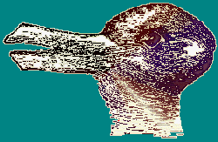
1. What two images do you see here?

2. Is this just a bunch of black boxes, or something else?

3. What two images do you see here?

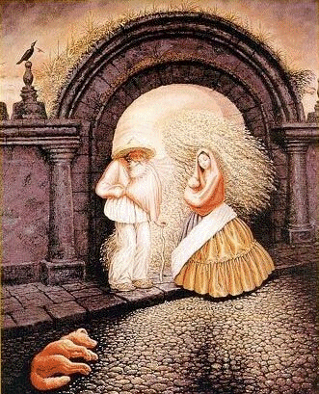
4. How many people are in this picture?
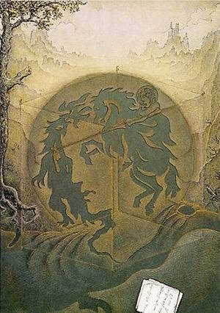
5. What images do you see here?

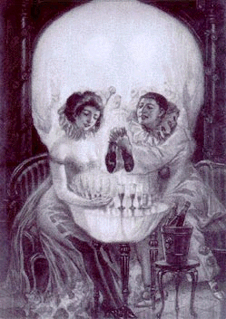
6. What images are portrayed here?

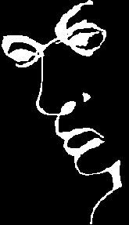
7. What image is portrayed here? What word?

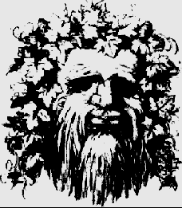
8. What two images do you see here?
9. What two images are shown here?

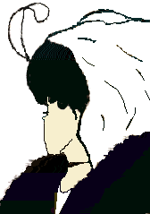
10. Who is pictured here?
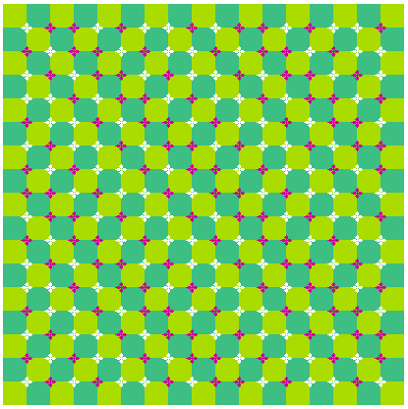
11. What effect is created here? (scroll down to see image move)

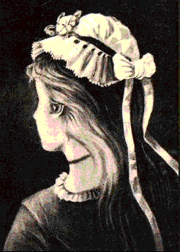
12. Who is pictured here?

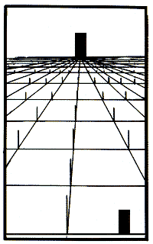
13. Which door is bigger?
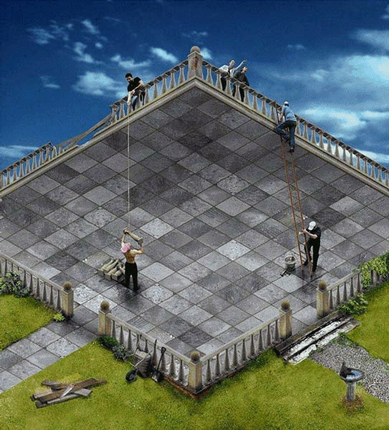
- Is this possible? Why or why not?

For more artistic optical illusions, visit: http://visualfunhouse.com/chalk_drawings/25-incrediable-3d-chalk-street-art.html
(and yes, they spelled "incredible" wrong.)

