Camouflage Toothpicks
Grade 5

Benchmarks
- “I can work individually, with a partner, and as a team to test a scientific concept, change a variable, and record the experimental outcome.”
- “ I can explain how traits of an organism affect its ability to survive in a given habitat.”
- “I can develop a data table to show the results of the observed traits within my class.”

Objective
Students will see how animals blend into their environment using camouflage.

Materials
Assorted colored toothpicks
Large grassy area
1 worksheet (for a bar graph) per student

Introduction:
Begin by introducing yourselves and telling the students what “type” of scientist you are (chemist, physicist, etc) and what you study! Please allot about 10 minutes for this!

Introduce the concept of camouflage as an animal adaptation. Explain that many animals have colors or markings on their fur, feathers, scales or skin that enables them to blend in with their habitat (the place where that animal lives). Ask the students how camouflage helps an animal survive. Ask for examples (a motionless green frog at the edge of a pond; drab brown feathers on most incubating female birds; winter white/summer brown colors of the arctic fox and ptarmigan, etc.). Are the reasons for camouflage of predators different from the reasons their prey have camouflage?

Use the cards with images of camouflaged animals to assist with this discussion.

- Present the students with the box of colored toothpicks and then write the total number for each color on the board
  - Orange = 50
  - Yellow = 50
  - Green = 50
  - Red = 50
  - Blue = 50
- Take the students outside and spread the toothpicks randomly over a large area of grass.
- Give the students 10 seconds to collect as many toothpicks as they can find – tell them to hold onto their toothpicks as you all go back into the classroom
- Count the number of each color of toothpicks and write that number on the board next to the original number
- Ask the students which colors were easiest to find? Which were more difficult? Why?
- (If you have extra time) Have the students create a bar graph plotting the number of each color that was found.
If you would like, pick a different area to spread the toothpicks. This could be the blacktop or maybe an area with dirt and no grass. Make sure it is approximately as large as the area you used in the grass. Repeat the experiment once more with the students.
- Did your numbers change? In what way? Why did they change?

Classification of Animals

If there is still time left over after the experiments and bar graphs have been completed, the worksheet attached could be something groups can work on together. The volunteers can lead group discussions with the kids.

- Give a brief explanation of how we classify animals. (There are many different animals in the world, but some animals are similar to other animals. Animals can have similar bones, skin, or similar camouflage)
- Give a brief explanation of vertebrates and invertebrates. Talk about the differences between them (invertebrates do not have a backbone or spinal column).
- Discuss the different types of vertebrates, and ask the class if they can think of any examples.
- Discuss the different types of invertebrates, and ask the class if they can think of any examples.

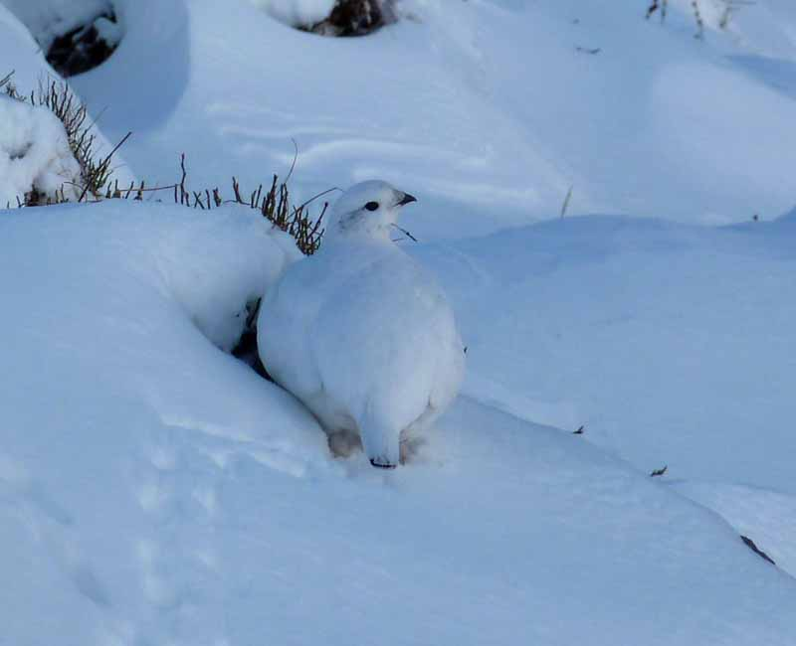
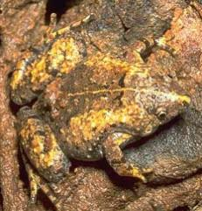

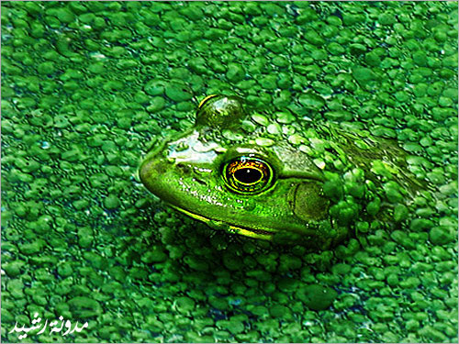

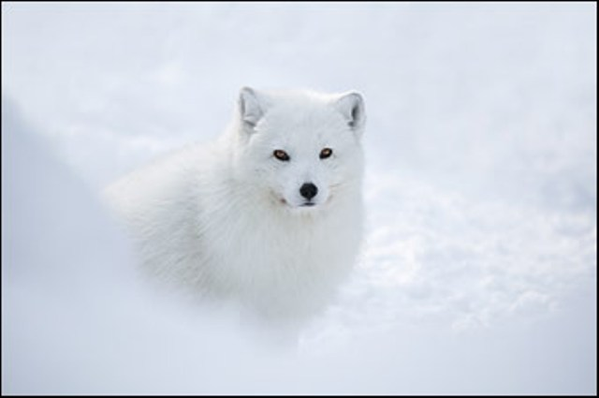
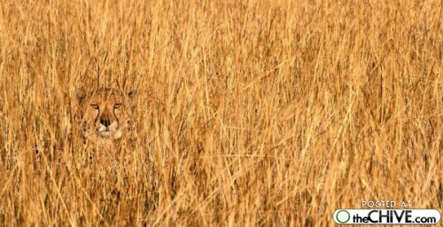
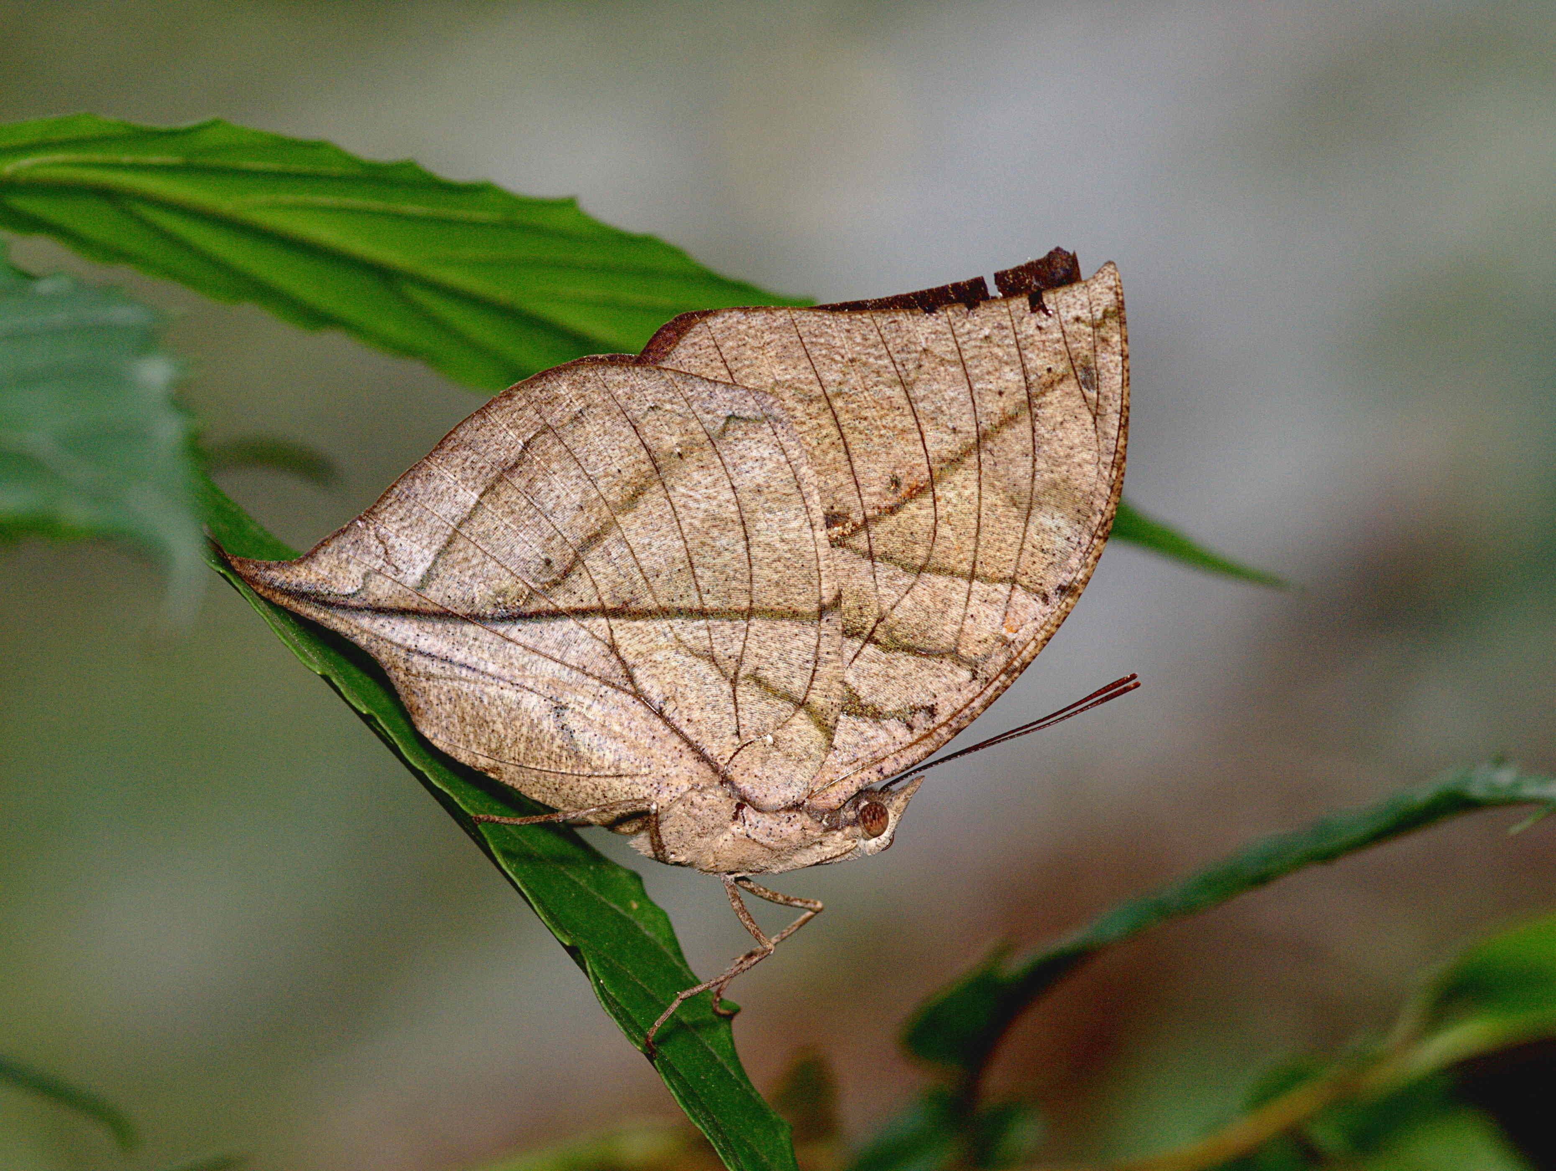

t

Color
Number

